Bargaining FAQs
- What’s happened so far?
We had nine bargaining sessions with UO’s team since November 2018. We made some progress on non-economic proposals but have not received more than one economic proposal from UO (and a slightly edited counterproposal that largely restated their original offer). We’re now heading into mediated bargaining soon—the first mediated session is planned for April 26th.

- What are we asking for? What have the UO’s proposals/counters been?
 | GTFF Proposals | UO Proposals
Healthcare | 100% premium coverage for GEs, partners, and children | A flat contribution of $1350 per GE per term, which results in a nearly 20% cut in their contribution to health insurance
Salaries | 9.25% increase to minimum salaries for each of the next three years—to reach UO’s calculated living wage | Add $696 (moved from healthcare premium and fee coverage into salary) to base salary as well as a 1% increase to all salaries for each of the next three years
Fees | Reduces GE fee responsibility to $0 for all terms (down from $61 during academic year terms and down from 65% of total fees in the summer) | Increase GE fee responsibility to 45% of fees during the academic year and 100% of summer fees. Shift the difference between $61 and 45% of current fees to salary. (Makes GEs vulnerable to fee increases)
Grievance Procedure | Countered with a pilot program that won’t change the current procedure without testing alternatives | Proposed significant changes to our grievance procedure
Summer Funding | $1200 summer bonus for each academic term worked | UO has not responded directly to this proposal.
Housing | Housing information sheet to be shared with incoming GEs and options for GEs in UO-operated housing to defer their first rent payment | UO has continued to insist that housing should not be part of bargaining.
Int’l GE Support | $500 flight subsidy, earlier notification of GE assignments, and an International Support GE position | UO has not responded directly to these proposals.
GE Parent Support | 12 weeks of paid parental leave, increased Grad Assistance funding for childcare (to $1000/child), and subsidies for childcare at UO and non-UO facilities | Rejected paid parental leave and childcare subsidies but proposed increasing Grad Assistance funding for childcare by $125 for a total of $700.
Support GE Positions | 2 LGBTQIA+ Support GEs, 2 Housing Support GEs, a Mental Health Support GE, an International Support GE, and a Discrimination and Harassment Support GE | Rejected these proposals and proposed a Graduate School-operated website that collates existing available resources.
Training and Professional Development | 6 hours of optional paid training and the inclusion of GES on departmental appointment and curriculum committees | UO has resisted both suggestions.
You can check out the 2018-19 Bargaining tab on the GTFF website (gtff3544.net) as well as the Bargaining Blog for more specifics regarding each of the GTFF’s proposals and a summary description of our RAISE platform. The Bargaining Blog has the proposals in their current state from the GTFF and from the UO.

- What is the timeline for action this term?
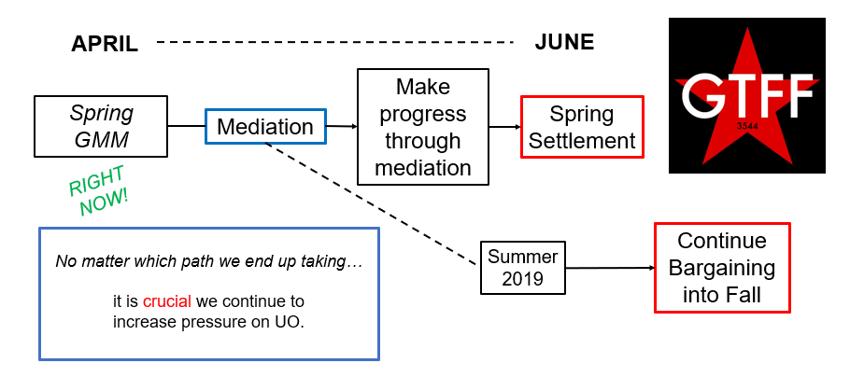
We called for mediation on April 8. Once we officially begin mediation (April 26), we are required to be in mediated bargaining for at least 15 calendar days—and hopefully until we reach a settlement later this term. After at least those 15 days have passed and no settlement has been reached, either side can declare impasse, which puts us on a different timeline for action (see Q5 for details!).
- What is mediation?
Mediation brings in a third-party mediator from the state Employment Relations Board (ERB) to facilitate bargaining between us and the UO.

- What is “impasse”?
After 15 days of mediation, either side and/or the mediator can decide that no further progress toward settlement can be made through mediation. Declaring “impasse” calls a halt to bargaining and both sides have seven days to submit their “last best offer.” After this offer begins a 30-day “cooling-off” period. At the end of that period, UO can impose its new contract and we, as GEs, can withhold our labor if we do not agree to that contract.

Talking to Students about Bargaining
Your undergrads can help support our efforts to put pressure on the university. Take a couple minutes before or after your class, lab, or discussion section to talk about bargaining and what they should know about the GTFF! Here are a few suggestions for starting that conversation.
- You are definitely allowed to talk about the union and our bargaining efforts to your undergrads (so long as it isn’t during work time)! As long as your sharing of union information doesn’t distract from your class, you are in the clear. Be careful though about doing this during class time, since that could be grounds for discipline if you’re using work time to talk union with students – to be safe, do this before or after class time.
- Wear your union gear! Your t-shirt, your buttons, your beanie—whatever you have. The more represented the GTFF is in your apparel, the more likely students are to ask you about it—an easy way to start that conversation.
  - If they really like your swag, the GTFF office has some buttons specifically designed for undergrad allies—share those with your invested students!
- The university will likely try to frame this as a question of tuition increases, trying to pit your undergrads against us (the “greedy grad students”). Let your students know that we’re simply asking for a living wage and health care and remind them that all university administrator and faculty salaries are available to the public. Share with them what a typical (and very busy!) day looks like for you!
- If your undergrads want to know how they can help, great! You can encourage them to:
  - Post on social media using the #GradsRAISEUO and #thankyourGE hashtags
  - Write “Letters to the Editor” of the Daily Emerald and other local publications in support of GEs
  - Get involved in our #thankyourGE video campaign—you or they can record a short video about the experiences they’ve had with GEs in their courses and post it on social media
  - Roll out to GTFF informational pickets, work-ins, and other public GTFF events

Talking to Faculty about Bargaining
Faculty can be another great resource for solidarity and support as we put pressure on the university. Here are a few suggestions and caveats about starting that conversation.
- GE labor helps faculty and instruction overall. They know this, you know this—make it clear that GES are asking to be treated as the employees (junior colleagues) that we are!
- The faculty union (UAUO) starts bargaining next year, and they may face a similar situation—let them know that GTFF stands in solidarity with them!
- Department heads are considered “managers,” and shouldn’t discuss bargaining with you because they can be seen as representatives of the university. Other folks? Chat with them!
- If faculty want to know how they can help, great! You can encourage them to:
  - Communicate with other faculty and administrators on campus in support of GE bargaining
  - Write letters to the editor of local newspapers in support of GE bargaining
  - Post on social media using the #GradsRAISEUO and #thankyourGE hashtags
  - Get involved in our #thankyourGE video campaign—you or they can record a short video about the experiences they’ve had with GEs assisting on their courses and post it on social media
  - Roll out to GTFF informational pickets, work-ins, and other public GTFF events

